spring 2025
Cse-4377 wireless communication systems
the university of texas at arlington


lab 1 report
Submitted toward the partial completion of the requirements for CSE 4377
Under the guidance of
Prof. Jason Losh
By:
Joshua Martinez, 1001374818

Introduction
Wireless communication systems can be defined as the transfer of data between at least two distinct locations without the need for physical connections. This lab introduces and focuses on certain beginning concepts of wireless communications, such as signal generation/transmission, and modulation. To cover these concepts, specialized equipment and circuits are required to gain the understanding how certain signals are generated, modulated, and then analyzed with the equipment. Thus, this lab grants hands-on experience in creating and working with modulation, IQ signal generation, spectral analysis, and root-raised cosine (rrc) filtering. To start this lab, an overall understanding of how the equipment works together to analyze a specified signal generation is needed.

MAIN P1 – IQ Signal Generation with Arbitrary Generator
To start this lab, it’s necessary to understand how the main equipment works using the arbitrary generator with its IQ inputs. Step 1 details connecting this generator, outputting 10 kHz cosine and sine, 1Vpeak-peak (0.5 amplitude), and 50 Ohm output mode, to the IQ inputs of the signal generator. The IQ, in-phase and quadrature, signals are two sinusoids with the same frequency but one having a phase shift of 90 degrees. Therefore, the I signal uses a sine wave and the Q signal uses a cosine wave. These types of signals are used in RF applications to perform RF signal modulation and demodulation, but for this lab we will focus on the former. The signal generator’s purpose is to generate radio frequency signals based on the input. It is set to have a 27.1 MHz frequency with its output set at -30 dBm with RF output enabled. These settings are predetermined to be a safe range as to not interfere with other systems and at a safe voltage to use with the spectrum analyzer. This is a device used to measure the strength of RF signals over a defined band of frequencies. The analyzer is set to27.1 MHz with a span of 100kHz to match the signal generator.
The next step requires enabling modulation from the signal generator to see its output on the analyzer. This will shift the carrier frequency of 100kHz which is the central point of the analyzer up by 10kHz. This change is the single-sided (upper sideband) modulation as the current range of frequencies is altered to be higher than the carrier frequency. Next, the I and Q inputs are reversed and become a lower sideband modulation, or a range of frequencies that are lower than the carrier frequency and cancels out the upper sideband. The last step for this section states to only connect the I input signal. With this change, a double-sided modulation is shown, or both sidebands being present on the analyzer, due to the lack of quadrature signal that helps remove one of the sidebands during modulation.

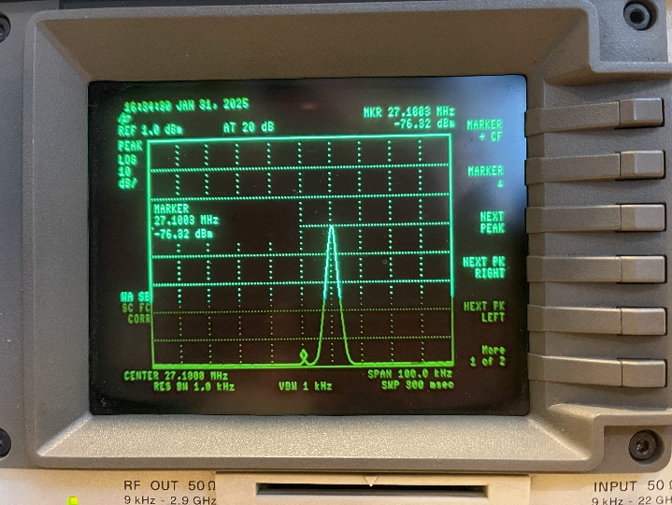
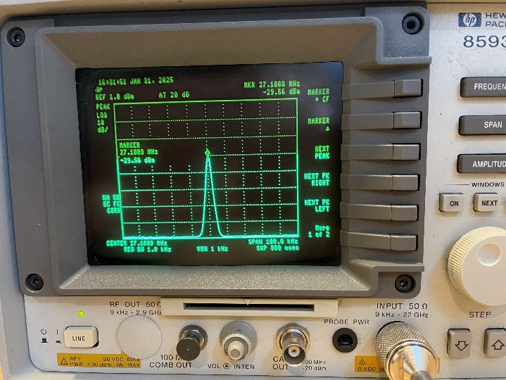
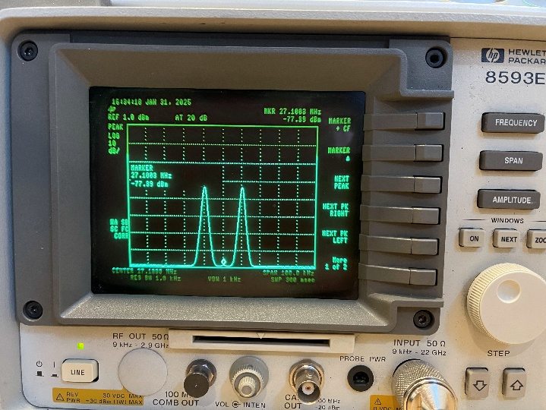
Images 1 & 2: Center frequency (left) and upper sideband (right) shown on the spectrum analyzer from arb. generator

Images 3: Double sideband on the spectrum analyzer

MAIN P2 – Circuit Creation
For steps 5 and 6, they detail the method to create the circuit for this, and future labs. The TM4C microcontroller will send information through a SPI connection to a 12-bit dual DAC, a MCP4822. This device offers an output range of 0V to 2.047V based on the 12-bit value it receives. An issue with the DAC alone is that it only produces positive voltage. To counteract this issue, the DAC will then be connected to a MAX660 switched capacitor voltage converter. This addition is a charge-pump voltage inverter that converts a voltage, +1.5V to 5.5V, to its corresponding negative output and gives us access to both positive and negative voltages. Afterwards, a TLC072 dual op-amp will handle the DAC outputs to generate our desired signals. These op-amps will be able to convert these signals to full AC signals due to the negative voltage from the MAX660. To test the circuit and verify its current abilities, software is needed on the TM4C. Using the given SPI list of commands, the TM4C will have certain pins configured to talk with the DAC. A function is required to compile a half-word message with the upper 4 bits detailing which DAC output, the gain, and the shutdown control; leaving the last 12-bits for our selected value between 0 and 4096. If configured/built correctly, a voltage should be set based on the input if the op-amp outputs are connected to an oscilloscope. Prior to moving to the next part, certain DAC values will be required to locate the voltages +/-0.5V and zero for both the IQ signals for the next step; thus, finishing this section.

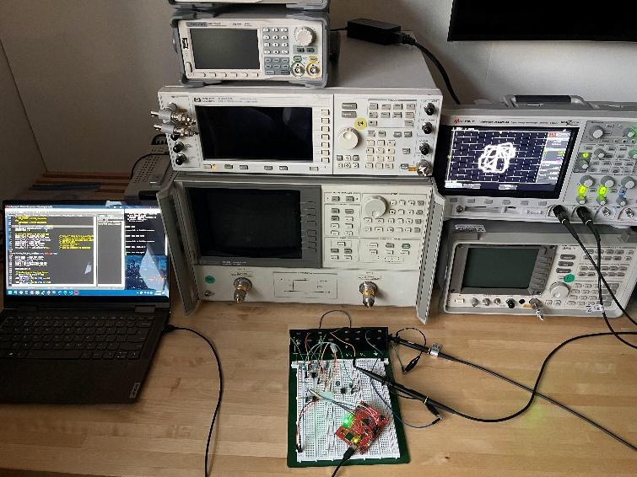
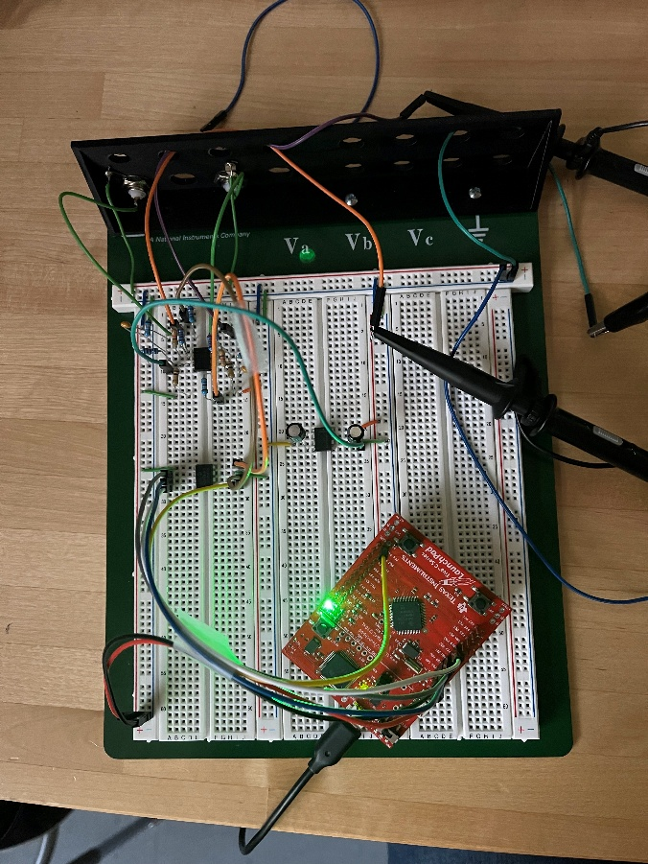

Images 4 & 5: The final circuit during demonstration, and the final setup during the lab

MAIN P3 – Modulation Testing
The next part for this lab is creating a command line through a UART connection to configure the DACs with a continuous cosine and sine outputs with a 0.5V amplitude and a 10 kHz frequency. In the prior step, we located the DAC values for the 0.5V amplitudes and will be used during the calculations of the DAC outputs when deciphering the frequency issue. As stated, a single hertz is the range of 0 to 2PI, for sine/cosine, whereas, the DAC has a value range of 0 to 4096. To begin this process, an array of the size of 4096 values will be needed. This array will be filled with values between sin(0) to sin(2PI), which are positive and negative float values. To lessen the memory taken on the board, these values are multiplied by 4096 and can be stored in an integer-based array. Afterwards, these values need to multiply by our input gain and offset to match our circuit. This offset is the zero value of the signals, or the average of the max and min of the DAC outputs. The equation can be described as the offset plus the offset multiplied by the amplitude and the selected array value. Using a for loop, two 4096 array tables can be filled to hold the values of the DACs to rotate through and create a hertz.
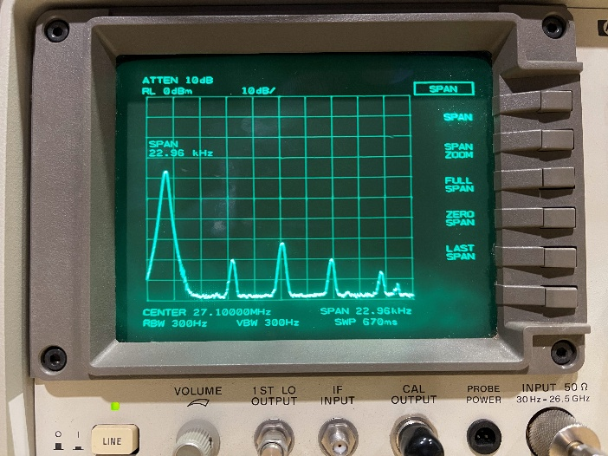
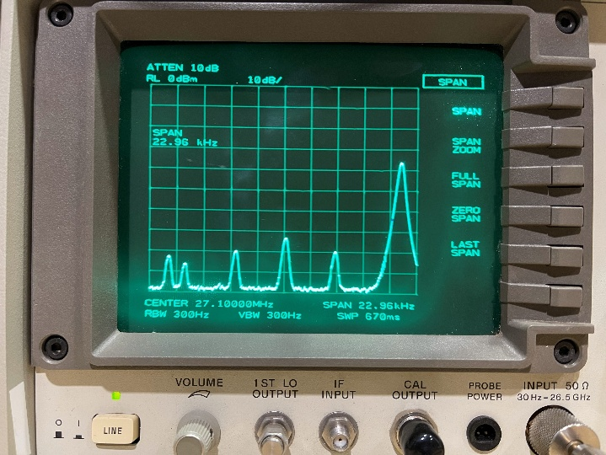
To have the pins set for the IQ signals, they need to run on an interrupt handler to output these waves. For these interruptions, they need to have their periods based on the system clock divided by the frequency input. An issue that arises is at a certain point the desired frequency causes the interruption period to become too small and no longer able to handle high wave outputs. Thus, we need to cut the amount of values output on the array. Stepping sizes are calculated based on the desired frequency and bit values of the DAC input. As noted above, one hertz is to be from 0 to 2PI, or 4096 values. If the stepping size were to be 2 instead of one, there would be 2048 possible locations but still output signals at a higher rate. These values are calculated up until the msb location or a stepping size of 2048, leaving 2 possible values for the highest input of 100 kHz. With these steps, the range of 1 to 100 kHz can be parsed into the interrupt handler period, noting the lower input the cleaner the signals are. Once completed and tested, the 10 kHz signal from the TM4C can be converted with the circuit to replace the arbitrary generator. By redoing the first part with our circuit, we examined the similarities and differences from these two signal outputs in the spectrum analyzer before moving onto the next section.

Images 6 & 7: Lower sideband is shown on the left, Upper sideband on the right
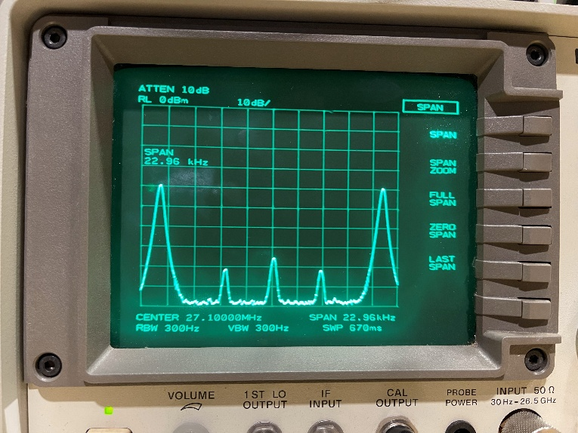

Images 8: Double sideband due to the disconnect of the Q signal

MAIN P4 – Symbol Streaming without filtering
After ensuring modulation is completed, the next steps involve recreating 4 types of modulation: bpsk (Binary phase-shift keying), qpsk (Quadrature phase-shift keying), 8psk (8-phase shift keying), and 16qam (16-quadrature amplitude modulation). As the TM4C doesn’t have much memory, each of these modulations will have their own double array to hold the IQ signals DAC values. For the bpsk version, it uses two phases, or points, to transmit one bit of information. In other words, the locations of -1/1, or the minimum and maximum values based on DAC, on the I signal signifies which bit, 0 or 1, is being sent while the Q signal remains at zero to limit the phases. Qpsk uses four phases to transmit two bits, 8psk transmits three bits using eight phases, and the 16qam uses sixteen phases to transmit four bits.
As a random number generator will not fit in our program, a bitstream of a specified value, such as 0 to F in hexadecimal in a 64 bit variable, will be used for transmitting these bits. Based on which modulation method is being used, grab their corresponding number of bits being transferred to the oscilloscope from the bitstream, using an incrementing value to keep track of the used values until it rolls over. This method will reduce the time needed to calculate and locate the symbol to output. The last step needed for modulation is the number of symbols to be sent each second when an interrupt handler is created for the modulation output, which is calculated by the system clock divided by the desired amount of symbols input through the command line. When completed and verified, these modulations are put through the same settings of the RF generator and spectrum analyzer to visualize the effect these outputs have on the center frequency.

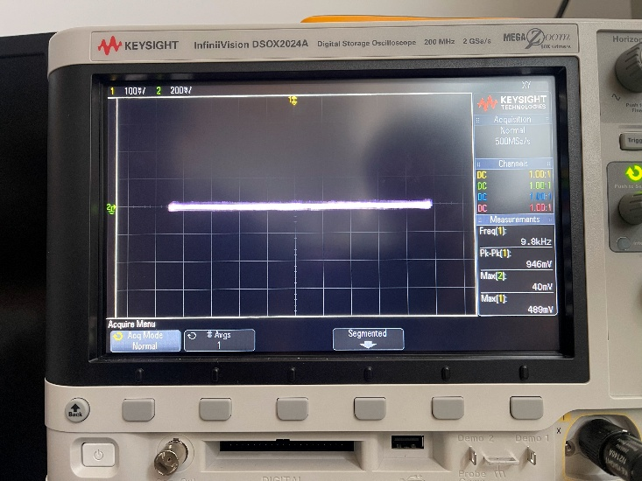
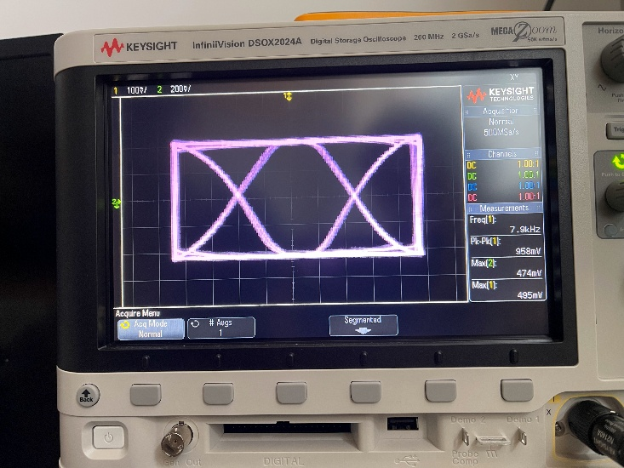

Images 9 & 10: BPSK (Left) and QPSK (Right) outputs on the oscilloscope on XY mode
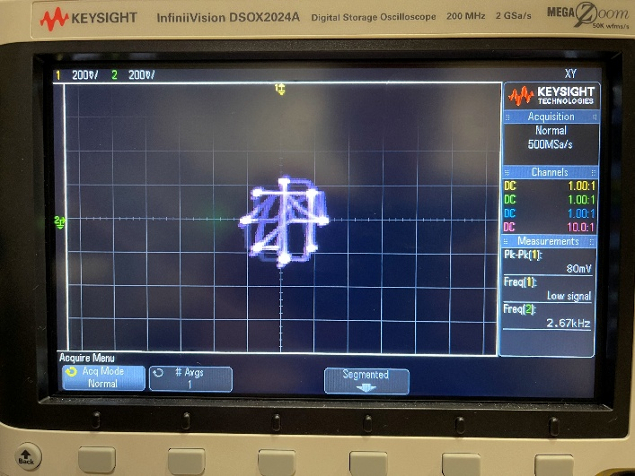
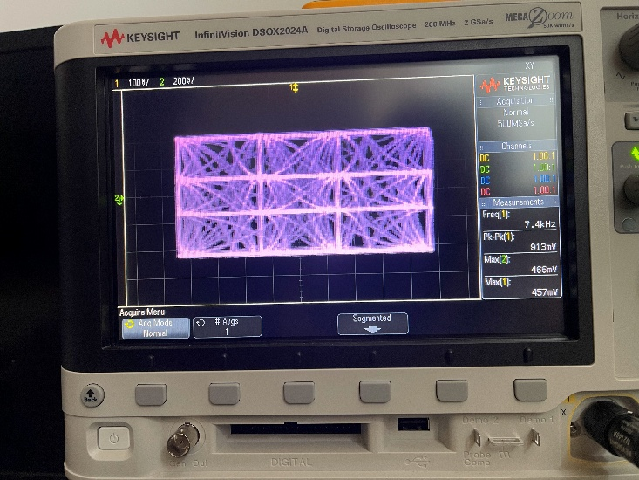

Images 11 & 12: 8PSK (Left) and 16QAM (Right) outputs on the oscilloscope on XY mode
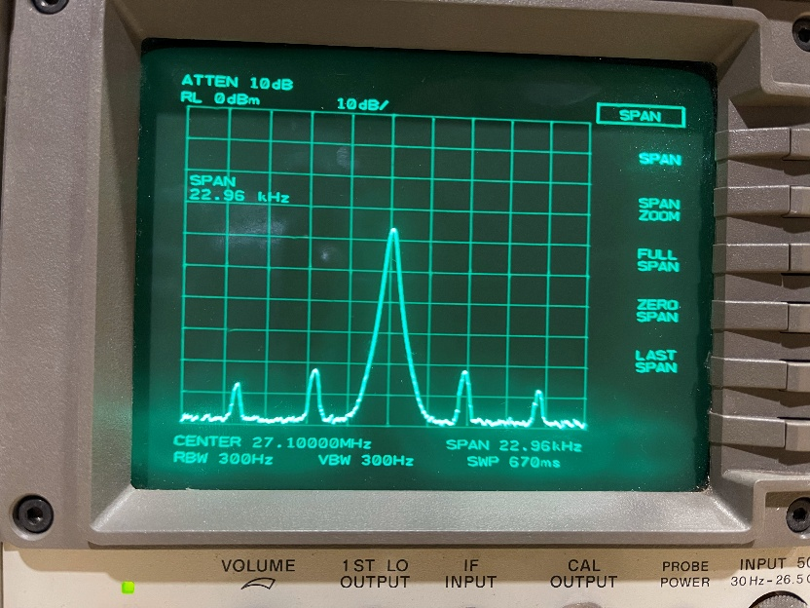
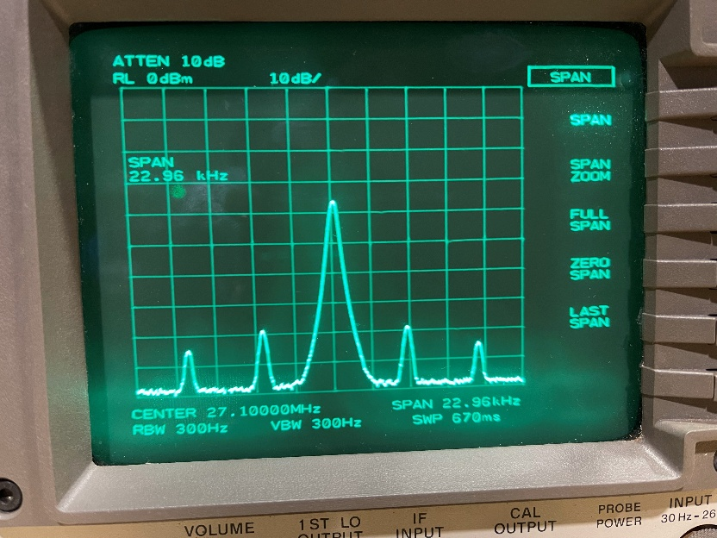

Images 13 & 14: BPSK and QPSK modulation on spectrum analyzer prior to filtering with lo symbol rate

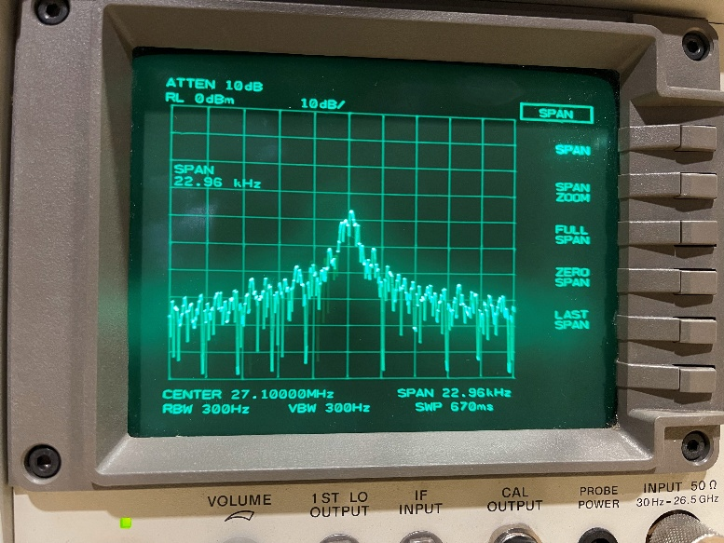
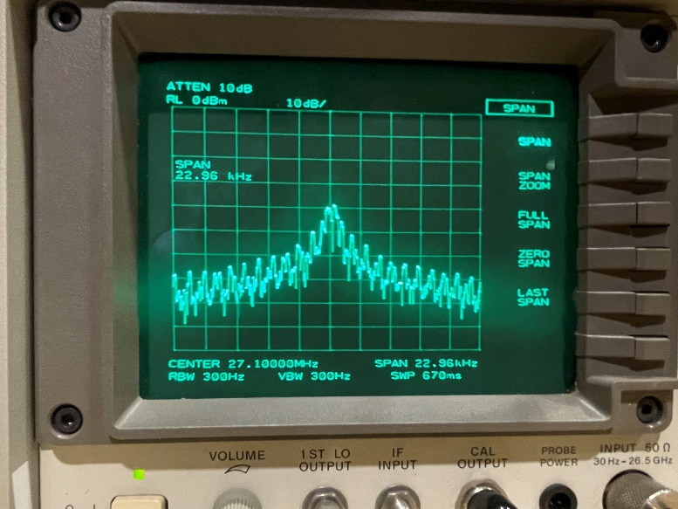

Images 15 & 16: BPSK and QPSK modulation on spectrum analyzer prior to filtering with high rate
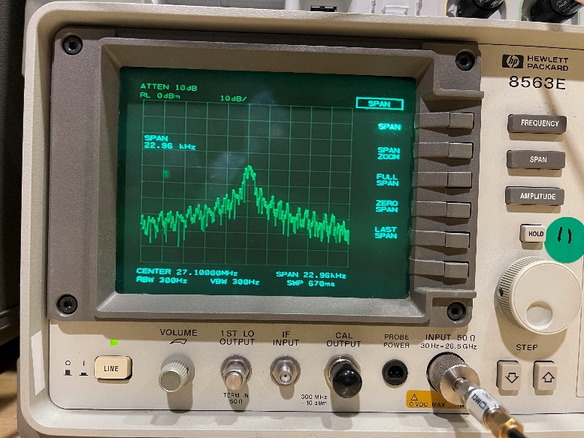
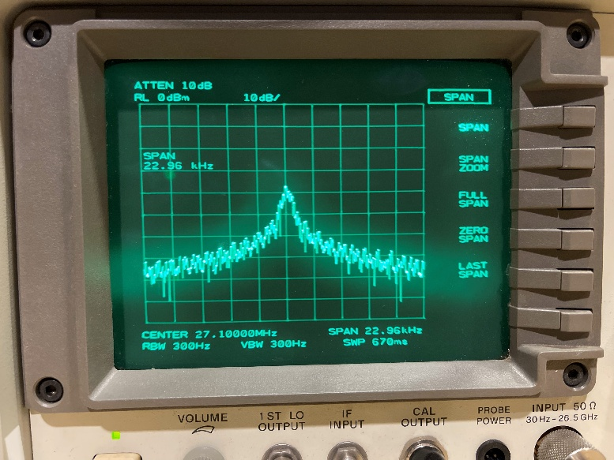

Images 17 & 18: 8PSK and 16QAM modulation on spectrum analyzer prior to filtering with high rate

MAIN P5 – Symbol Streaming with filtering
Finally, the remaining part of this lab include adding an RRC filtering command line option to the modulation. Rather than streaming the grabbed bits right away, they will be placed in a circular array and be multiplied via a 30th order RRC filter array. These values will be stored with three zeros between them based on this filter. These delays allow the DAC output to not interfere with the upcoming output, reducing the voltage spikes that occur. Another important factor from this filter is, during convolution, the output values between grabbed bits have strength based on previous bits to ease the transition to future outputs. Therefore, filtering allows a feathering effect between modulation outputs to reduce the voltage spikes that occur. When these steps are verified and tested, the IQ signals are to be run through the RF generator and the spectrum analyzer as well to visualize their effect on the center frequency compared to the previous steps.
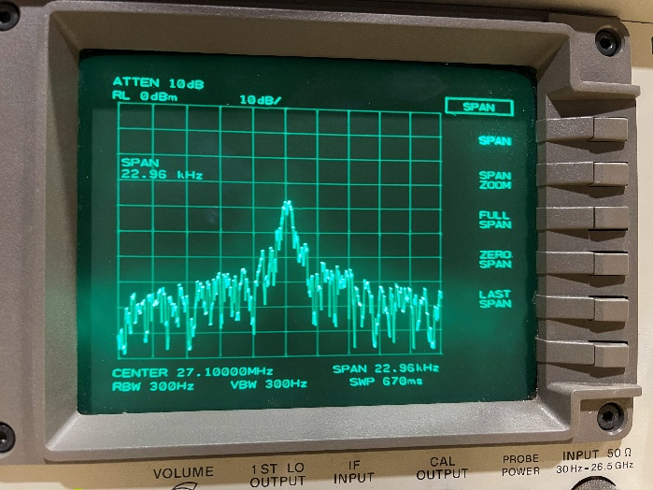
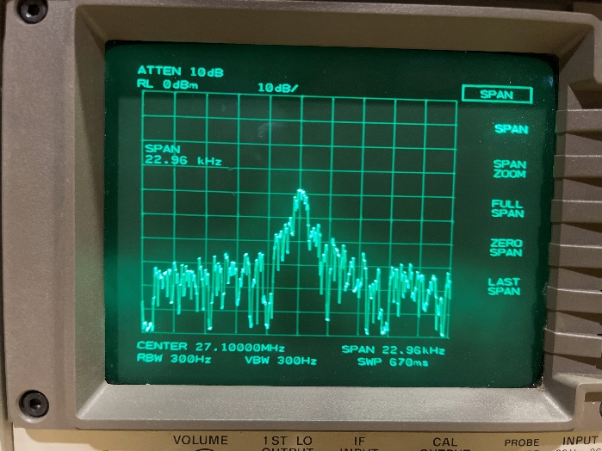
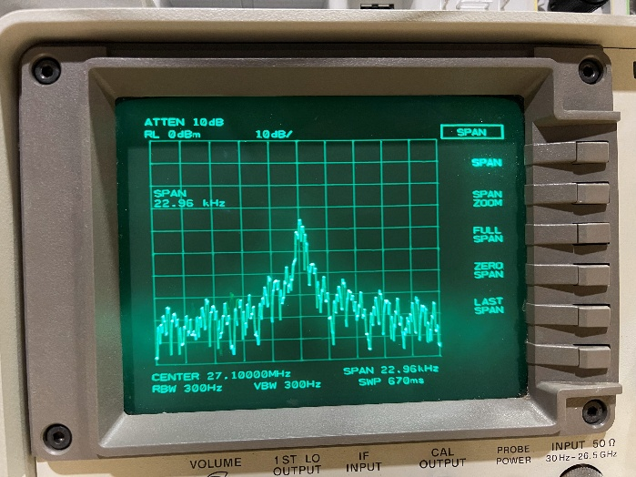

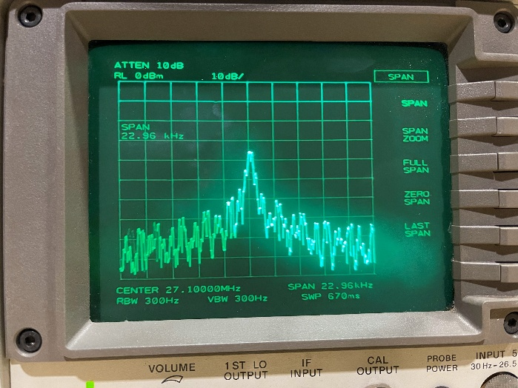
Images 19 & 20: BPSK and QPSK modulation on spectrum analyzer with filtering with high rate

Images 21 & 22: 8PSK and 16QAM modulation on spectrum analyzer with filtering with high rate

Conclusion – Final
This lab was an introduction to wireless communication concepts, such as modulation, IQ signals/generations, and RRC filtering. Equipment such as the arbitrary generator, RF signal generator with external IQ modulation inputs, an oscilloscope, and an RF spectrum analyzer gave us a method to view these concepts in practice. To better understand these concepts, this lab required creating our own set of IQ signals using the TM4C microcontroller, a dual DAC, OP Amps, and a voltage converter running a specified list of code to replace the arbitrary generator. Through the creation of the code to output signals and modulation came a better understanding of the math and methods required for signal generation.

